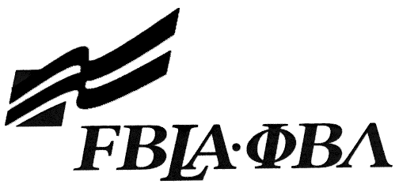 FBLA Statement of Assurance

Puget Sound FBLA Winter Conference Form

This form must be completed and submitted by Friday, January 13 for the Puget Sound FBLA Winter Conference competitions. If the event has other materials to be submitted, include this form in the zipped folder to be uploaded.

Check one: 3D Animation Computer Game & Simulation Programming
Coding & Programming Digital Video Production
E-business Mobile Application Development Website Design

Provide the complete URL for E-business, Digital Video Production, and Website Design. These events will be judged online. Make sure the URL link is valid.

KEY INFORMATION
State: | Washington
School: |  | Federal Way High School
Website URL Address: (where appropriate—must have full address)
Member(s) Name: |  | Simon Struthers
Local Chapter Contact
Name: | Norma O'Malley
Daytime/Cell Number: | (206) 679-0696
Home E-mail: | nomalley@fwps.org
I/We, the undersigned, attest that the design, creation, and implementation of the event are the original work of the above chapter member(s). I/we agree that this event may be linked, promoted, and used in any way by the national FBLA-PBL, Inc. for purposes of promoting the organization. (Typed name is accepted for signature)
Name of Team Member  Simon Struthers |  | Adviser’s Name  Norma O'Malley
Name of Team Member |  | Name of Team Member
Complete this Document Section for the Above Events if Applicable
Software Used: | Python IDLE, paint.NET
Source of Information: | Citations found in project as "citations.txt"
Copyright Notations | All images are free to use or are under Creative Commons license.
Instructions for Running Project: | If an executable file is available, simply run it as is.
Template(s) Used (source) | N/A

